Sample Calculation for Lab 04
Repeat in great detail the following derivation

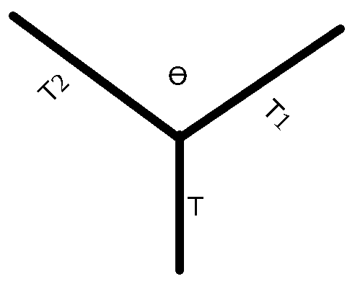
In the image above, we have the following tensions
.
We assume that the angle Θ is equally divided up the bisector. So that in fact the angle we will use is divided by 2, and I will call that φ.
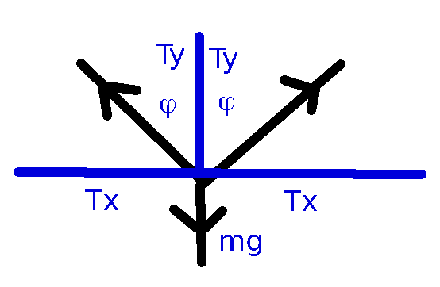

But we know that

because the strings on either side are holding up the same mass m. So:

This gives us the expected angle between the two strings to be a total of

