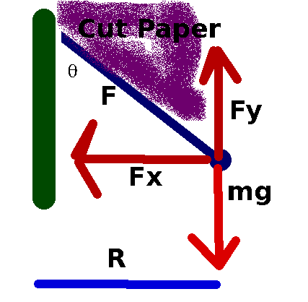

Note that I have indicated with purple shading where to place the cut paper in order to measure the angle θ. I will discuss this later. The ball is assumed to be orbiting the green object thing.

The analysis:
The string has a tension F.
We can resolve this into x and y components:

Newton’s law says:

Apply this now:

This is a central force. According to Newton’s laws we then have:

where v is the tangential speed and R is the radius of orbit.

I will show you below how to measure this velocity at home.

where T is the time that it takes for one complete rotation which is called the period.
From the geometry of the problem, we have:

where L is the length of the string (11 inches).

We are going to use this in :

So:

However here, the metronome timing will give frequency instead of period. The period you will choose here is 60 bpm or f=1 Hz which gives a period of T=1 second. The connection between frequency and period is:

.

Using this we then have:

In principle, we could measure g with this. However, owing to the equipment that is being used, it won’t give a very good value for g. I have another technique in another lab that will measure g.

Today your measurement of θ and a comparison to the expected value will give an indication of the validity of our treatment. You might call this the “conical pendulum” if you like.

As a note, my measurements did not actually produce wonderful results. I would regard this as an indicator towards the validity of our analysis. However friction in the system and the necessity to continually pump energy into the system, combined with the timing and the inaccuracy in the angle measurement definitely contribute to the large % difference. I suggest trying to make the measurement several times.
The experiment

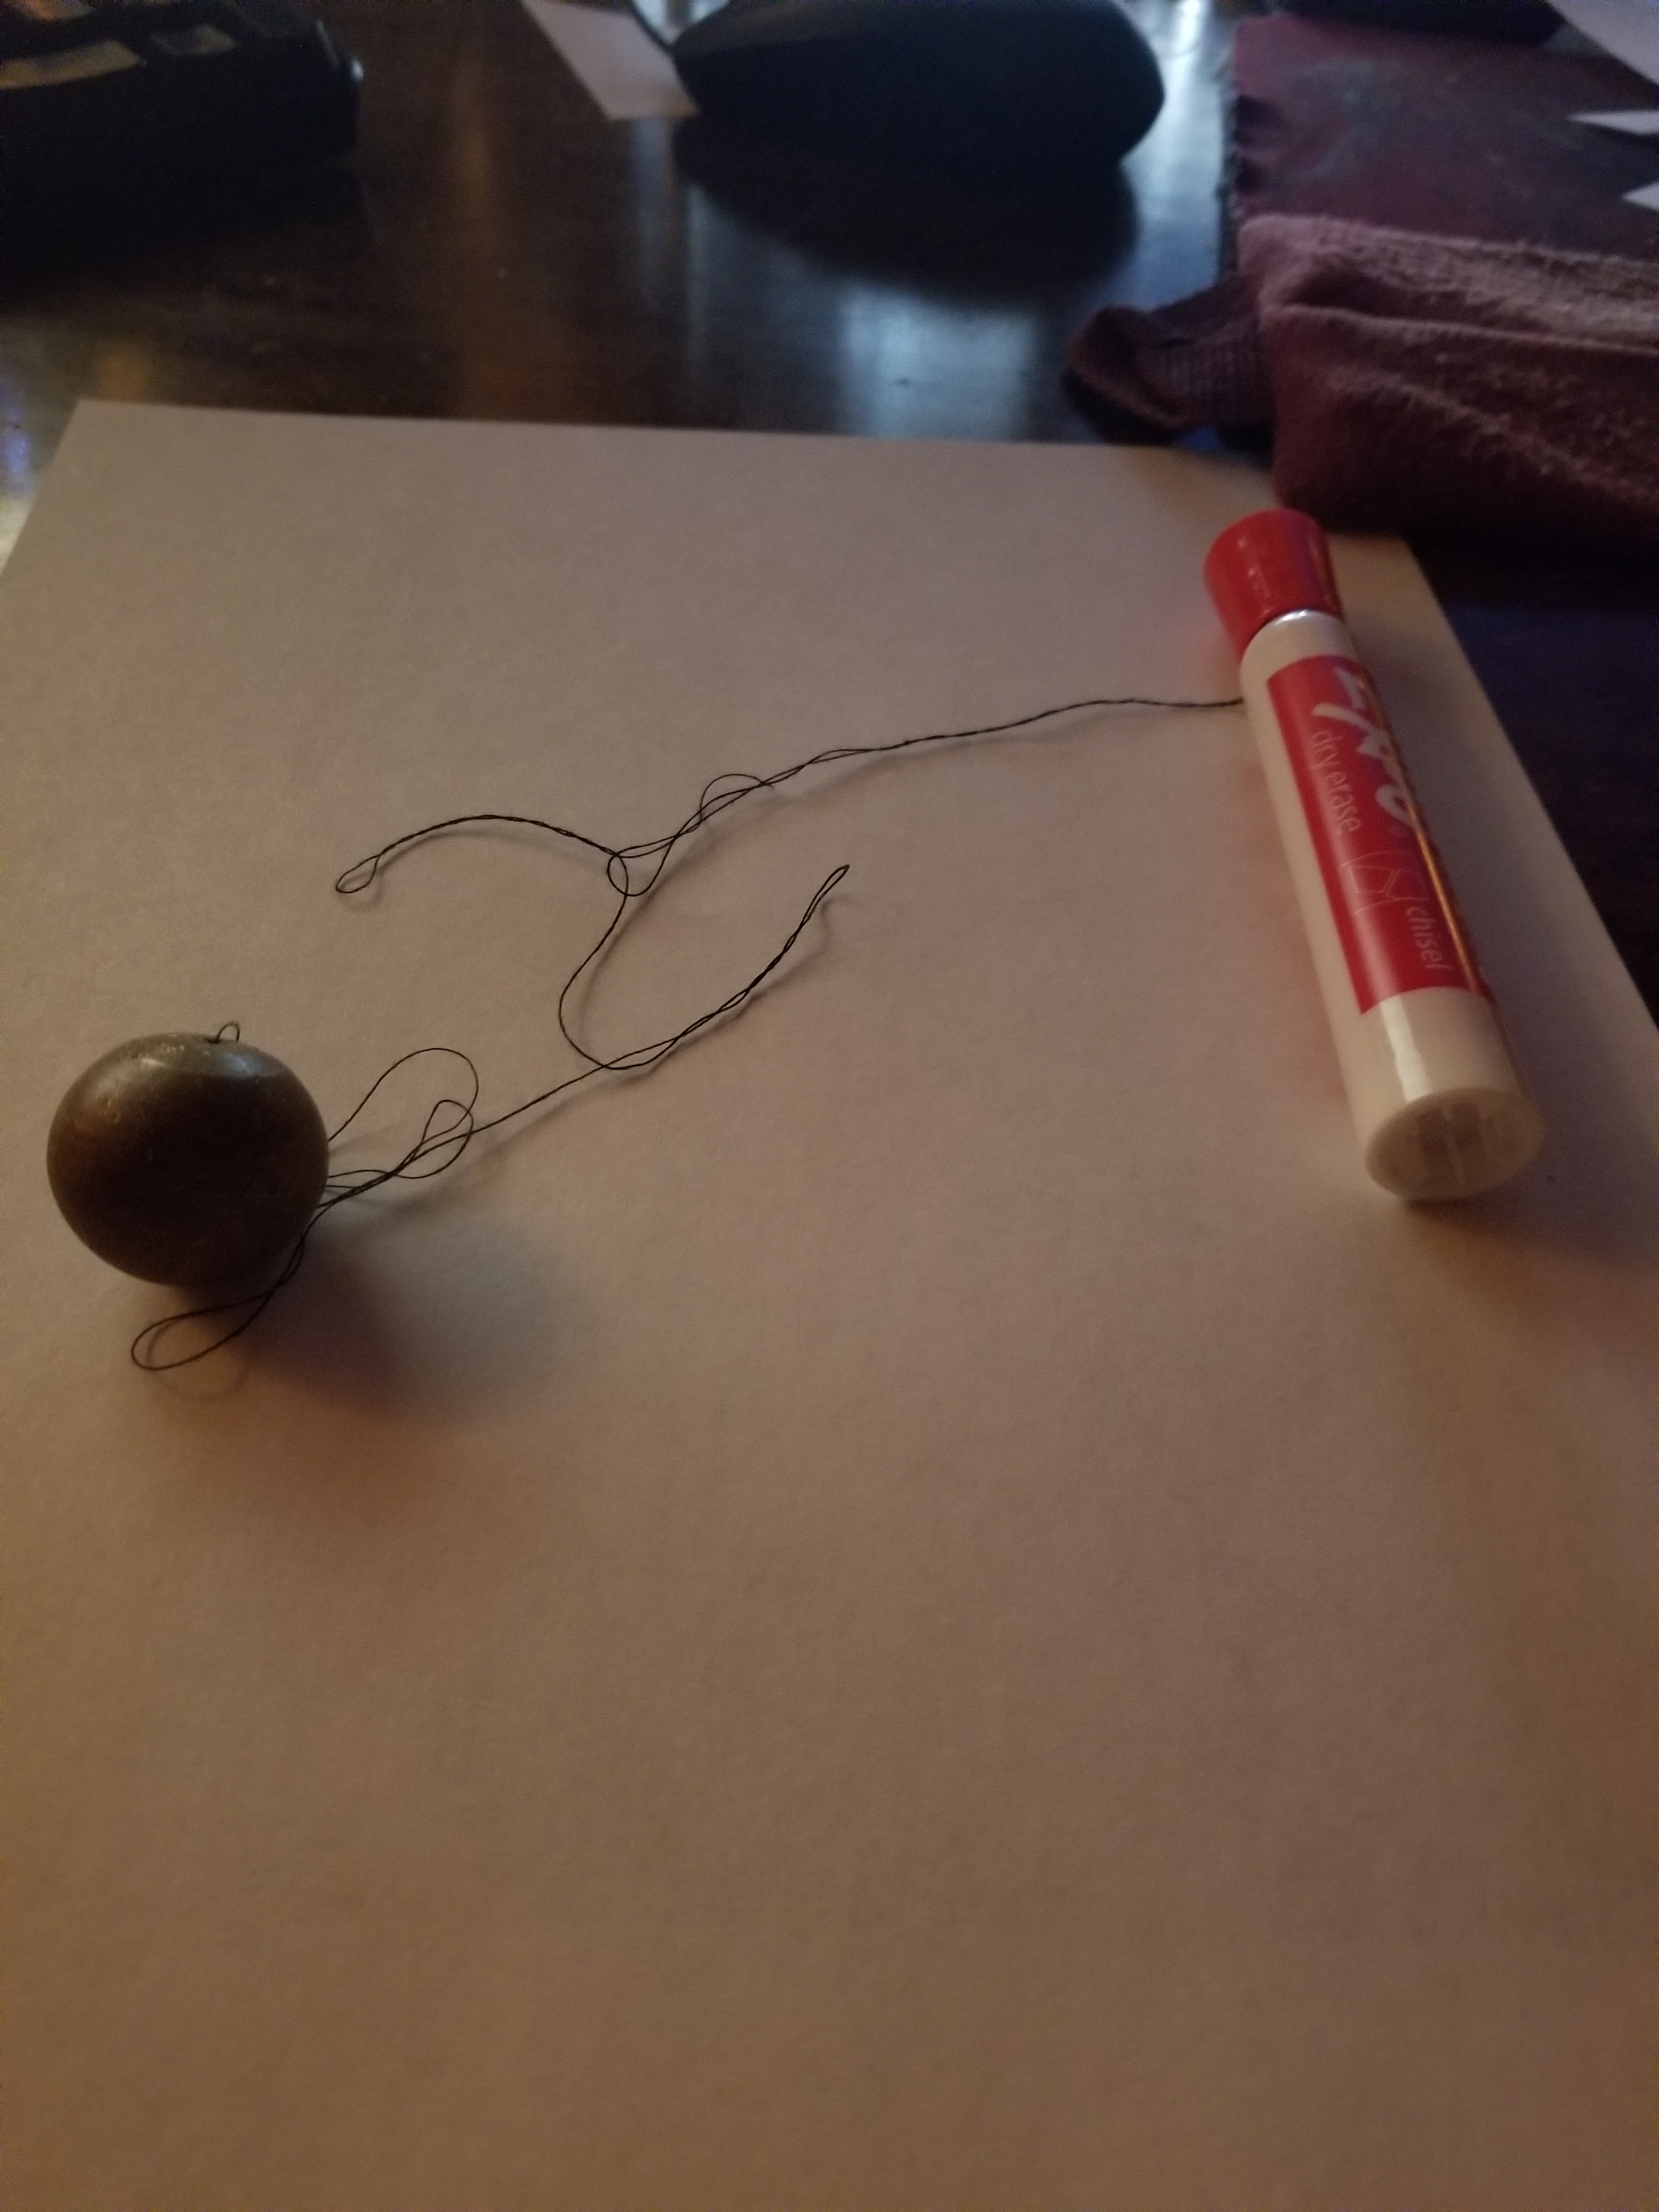
T is measured with a metronome. I got one by a google search with the word metronome. This is the link for that:
https://www.google.com/search?q=metronome
Set the frequency to be 60 bpm which is a frequency of 1 Hz.

The idea is to adjust your swing rhythm to match that of the metronome beats. It takes about a minute or so to get this rhythm down.

Your string is the size of the long side of a standard sheet of paper (11 inches) because I realized not everyone has a ruler at home. You might need it slightly longer to make knots. Tie your nut (a fairly large nut and since I used a ball, I will say ball below) to one end and make a small loop on the other end. This will go over something smooth with a notch as I have indicated in the photo. If you use what I did, do not put the cap on all the way otherwise it might pinch the string. I tried a mechanical pencil but it did not work as good.

Stand up, with the ball below your hand, it should orbit at about your waist. Practice a bit. I found when the metronome makes a beat, find something in the distance to look at so and the idea is to time your rotations so that each time you hear a beat, you see the ball in front of that distant object. Be sure to have your hand above the ball and not below it. Otherwise, you will get whacked in the head most likely. You will also want to stand away from things like glass and computer monitors and other things to break here, just in case the thread breaks.

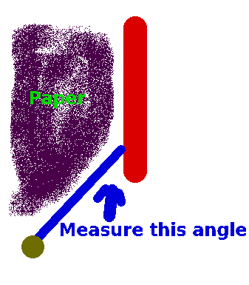
Now get good at swinging the ball with a frequency of 1 Hz (60 bpm). Next you will need to measure the angle shown below while the ball is rotating at a frequency of 1 Hz. I tried several methods and here is what worked for me: I cut the corner on a piece of paper with scissors and slid it down the red marker pen (it is a good idea to make a mark on the side parallel to the pen for later reference. I started out with a fairly small angle. I kept cutting off the paper at a larger and larger angle until I could hold the paper in one hand, and rotate the ball with the other hand and it might barely strike the paper. I then held the paper up and measured the angle with the clineometer. If your nut is large enough, this ought to work fairly well. I do think you probably will want to use my technique to measure the angle: I have a short video on the lab website showing this.
The angle will be somewhere between 25 and 40 degrees if you do this correctly however I believe that it is entirely possible that this part of the lab will not give great results because of the angle measurement. I have a spreadsheet just for the calculation.

